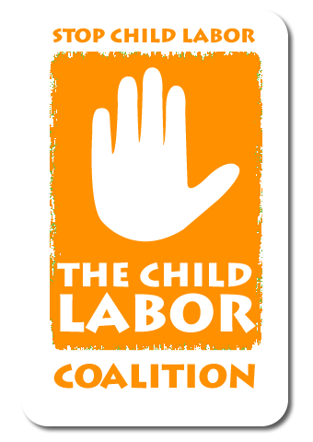
Child Labor Coalition
1701 K Street, NW, Suite 1200, Washington, DC 20006
Phone 202.207.2820 Fax 202.835.0747
www.stopchildlabor.org

April 27, 2015

Mr. Richard Burrows
Chairman
British American Tobacco PLC
Globe House
4 Temple Place
London WC2R 2PG
United Kingdom

Dear Mr. Burrows:
On June 24, 2014, a collection of organizations representing millions of Americans, including teachers, healthcare professionals, workers, farmworkers, and advocates concerned about children working in the tobacco fields wrote an open letter to the tobacco industry, outlining a number of steps that must be taken to eliminate child labor from tobacco supply chains.
We are heartened that your company has expressed interest in implementing stronger policies to end child labor in tobacco fields. However, as we noted in our letter, enacting higher standards is only a portion of the solution. To truly address the problem of child labor in tobacco, effective reporting mechanisms must be established in the fields, and adult workers must receive wages that allow them to support their families and send their children to school rather than work.
This is why we are writing you again, in support of efforts by the Farm Labor Organizing Committee (FLOC) to establish a system for tobacco farm workers in North Carolina to negotiate for better wages, improved working conditions, and establish a committee that can resolve issues for tobacco workers and growers when they arise. We ask that you sign a Memorandum of Understanding (MOU) with FLOC to negotiate recognition of the Dunlop Commission regarding tobacco growers and farmworkers in your supply chain. The Dunlop Commission has been successful in the past in establishing a private system of union recognition and dispute resolution between corporations, growers and workers. The Commission would set out rules and regulations, with participation of all sides, to mediate differences and address the long-term challenges workers and their families face in the tobacco industry. The expansion of the Dunlop Commission proposed by FLOC establishes field-based monitoring and resolution systems for labor rights abuses, including child labor, and makes provisions for remedies when appropriate. This would be an important counterpart to your increased commitments to end child labor.
Tobacco harvesting is hazardous work unsuitable for children, whose bodies and brains are still developing. Research has found that children working in tobacco are especially vulnerable to nicotine poisoning (green tobacco sickness), cancer, health problems from pesticide exposure, injuries from working with dangerous tools and climbing significant heights in curing barns, and respiratory problems from breathing tobacco dust. Most of the workers in the field do not expose their children to these hazards willingly, but out of necessity because of the low wages paid to tobacco harvesters. A 2010 study conducted by Oxfam America found that a quarter of workers surveyed in North Carolina—22 out of 86—were paid less than the federally mandated minimum wage of $7.25 per hour, and 57 workers said that their pay was not enough to meet their basic needs. Furthermore, it found that tobacco pricing mechanisms made it difficult for growers to provide adequately for field workers.
While training, education, regulations, and standards are all important pieces to solve problems in the tobacco supply chain, we believe that higher wages and improved working conditions obtained through a collective bargaining process are critical elements to a solution that leads to the elimination of child labor. Guaranteed the right to negotiate directly to improve conditions in the fields, farmworkers will be able to engage with the appropriate parties to be part of the solution to address labor issues. This approach will provide much more sustainable changes than any top-down approach and empower tobacco growing communities to address the root causes of child labor.
With this in mind, we urge you to boost your efforts to combat child labor by signing an agreement with FLOC to participate in the Dunlop Commission process. The Child Labor Coalition (CLC), its 35 members, and the additional 33vgroups that have signed on in support of this letter await a positive response and will continue to be in contact until this issue is resolved. You can reach Reid Maki, CLC coordinator, at 202-207-2820 if you would like to discuss this letter and our support for the farmworker efforts.
Sincerely,
9to5
American Federation of Labor and Congress of Industrial Organizations (AFL- CIO)
American Federation of Teachers
Association of Farmworker Opportunity Programs
Beyond Borders
California Institute for Rural Studies
Catholic Migrant Farmworker Network
Center for Latino Progress
Child Labor Coalition
Delaware Ecumenical Council on Children and Families
El Comite de Apoyo a Los Trabajadores Agricolas
Farmworker Association of Florida
Farmworker Justice
Food Chain Workers Alliance
Free The Slaves
International Brotherhood of the Teamsters
International Labor Rights Forum
Jobs with Justice
Latino Advocacy Coalition of Henderson County
League of United Latin American Citizens
Massachusetts Coalition for Occupational Safety & Health
Media Voices for Children
Migrant Clinicians Network
National Consumers League
National Education Association
National Farm Worker Ministry
Puente de la Costa Sur
Sisters of Charity of the Blessed Virgin Mary, Dubuque, Iowa
The Episcopal Church
The Ramsay Merriam Fund
The United Methodist Church – General Board of Church and Society
United Church of Christ Justice and Witness Ministries
United Food & Commercial Workers International Union
United Mine Workers of America
Youth and Young Adult Network of the National Farm Worker Ministry

